Index

Chapter 1: Clash of First Impressions
Chapter 2: The Charmer Arrives
Chapter 3: One Friend, One Foe
Chapter 4: The Prank, War Begins
Chapter 5: It Wasn’t Just Dinner
Chapter 6: The Passenger Seat
Chapter 7: Reunion
Chapter 8: Unspoken Ties
Chapter 9: Shifting Equations
Chapter 10: The Ride Home
Chapter 11:

- "The Hidden Past" – Highlighting Tushar’s secret about knowing Sia.
- "Lines Are Drawn" – If tensions between Ivaan and Sia (or others) escalate further.
- "A Game of Secrets" – If more secrets start to unfold in this chapter.

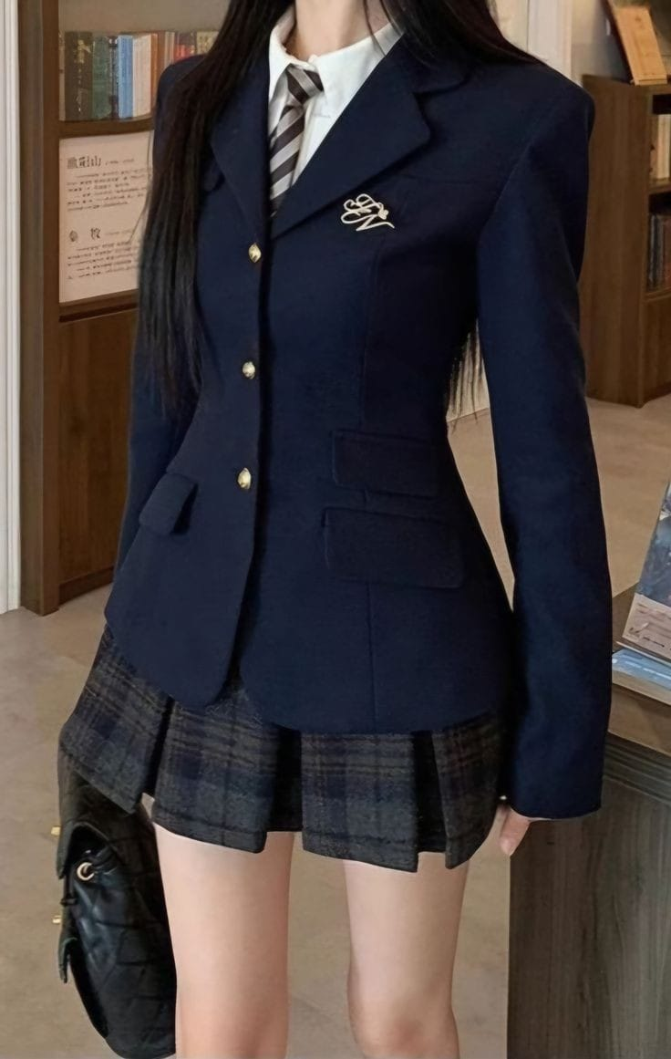
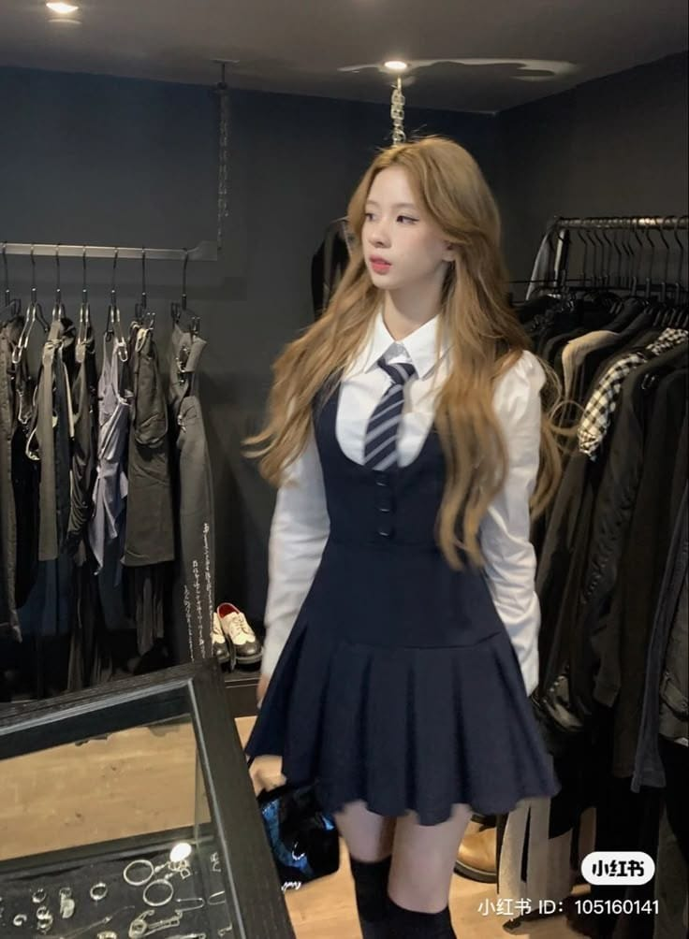
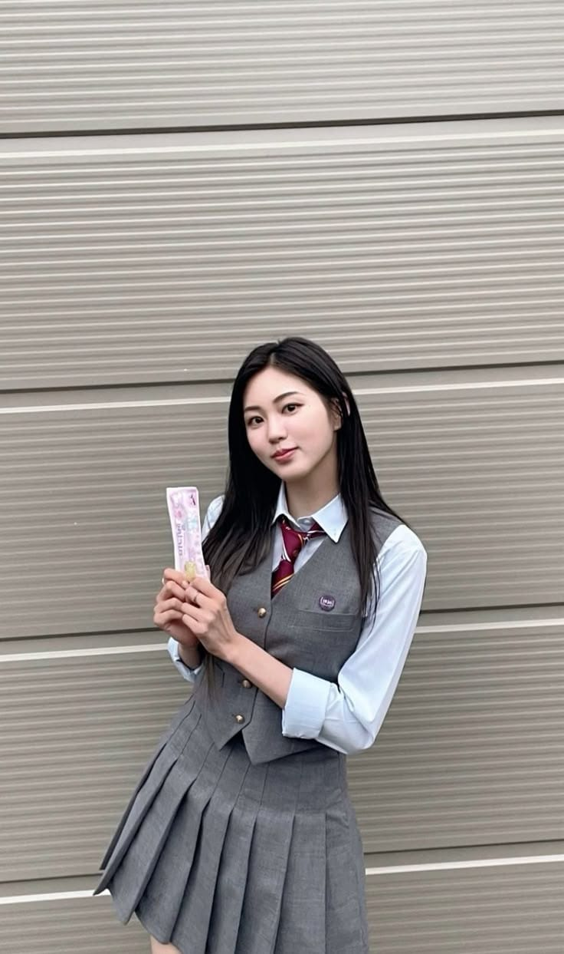
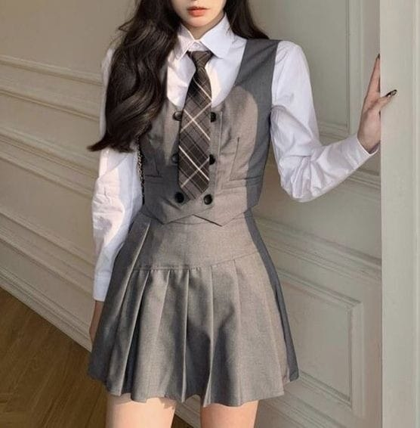
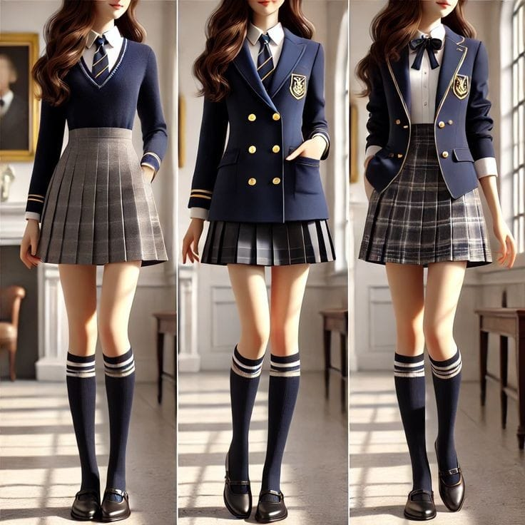

“Tangled in love”

Chapter 1: Clash of First Impressions
--Morning at the Merchant house--
(The sun was bright, but inside Sia’s heart, a storm was brewing. Today marked her first day at her new school, and nerves twisted inside her like tangled wires.)
(Sia gets ready for school and went downstairs)
Mrs. Merchant (Sia’s mom): Oh, Sia you are ready….? (she picks her bag in hurry
)…Bacha I am getting late for work. Your breakfast is on table and the driver will take you to your school. Okay? So, take care. Bye!
Sia: But maa….
Mrs. Merchant: I am getting late bacha. Bye. (She rushed out)
Sia: Bye. (with a sad face)
(Sia sighs, staring at the empty doorway. Her mother is always busy. This isn’t new. She has her breakfast and heading to school, gripping her bag tightly.)
--Arriving at Elite High--
(Standing outside the massive gate, Sia takes a deep breath.)
Sia (to herself): So, this is the Elite high international school everyone’s hyped about. Let’s hope the first day goes well (She sighs, then force a smile.) let’s go.
(She walks into the crowded school hallway. The buzz of conversations, laughter, and footsteps surrounds her. She looks around and find a group of students is looking at her murmuring something. She takes a deep breath and try to relax. but then ---)
--FLASHBACK--
(Loud voices. Judging eye. A circle of students staring at her. The sound of whispers fills her ears. Something tightens in her chest.)
--Back to reality—
(She gasps, her body stiffening. she covers her ears, trying to block out the noise.)
Sia (in her mind): (No, no, no, no………)
(She needs to get out of here, she tries to escape the hallway, pushing the past, “BAM!” , she bumped into someone hard, almost losing her balance.)
Sia: shit! I am so sorry! I am so sorry…… (she doesn’t look at the person and just runs away.)
(She finally reaches a quieter corridor and looks at her watch.)
Sia (Groans): Great. School ke phale hi din late hone ka plan hai kya? Bhag Sia……
(She takes a deep breath and finds her way to her new classroom.)
(Sia enters in the class with some hesitation and quickly grabs a seat at back and she exhales deeply, trying to calm herself down. Just then a boy walks in confidently, he is tall, handsome with sharp personality, beautiful sharp eyes and amazing hairs. Whole class is looking at him, but Sia is already put her head down, she didn’t look up. He walks to backside and throws his bag onto the desk in front of her.)
???: Hey, move, this is my seat. (In rude way)
(Sia looks up to see a tall guy with intense eyes and a sharp jawline, staring down at her with crossed arms.)
Sia (raising a brow): why? Have you reserved this seat?
???: Yes.
Sia: I don’t see your name written on it.
(He pulls a pen from his pocket and, without hesitation, scribbles his name on the desk. “Ivaan”)
Ivaan: See? Now you do.
(Sia blinks in disbelief. The students around them go silent, watching intently.)
Sia: Are you serious?
Ivaan: Dead serious. Move. (a little tough and high voice)
(Sia folds her arms, her competitive side kicking in.)
Sia: Mai yaha pahle bethi thi toh tum koi aur jagah dudhlo. (Some nearby students start whispering, excited by the unexpected showdown.)
Random Student 1: Oh damn, is she seriously arguing with Oberoi?
Random Student 2: She’s new. Maybe she doesn’t know who he is.
Ivaan: look, Newbie, ye meri seat hai jaha mai har roz oh Bethta hu. So, move before you embarrass yourself more.
Sia: what’s your problem?
Ivaan: You don’t want to start your first day by messing with the wrong person.
Sia: Or maybe you’re not used to someone standing up to you?
(A few Students snicker at her comeback. Ivan clenches his jaw, clearly annoyed. Now before he could add something. The room instantly falls silent as Mr. Joey walks in.)
Mr. Joey (Homeroom teacher): (Eyeing them) What’s going on here?
(Ivaan Straightens up, but Sia just calmly looks away.)
Ivaan: Nothing, sir.
Mr. Joey (looked at Sia): Ah, our new Student. Miss. Merchant, right?
(All class’s eyes on Sia now. Sia nods. Students start murmuring. Mr. Joey glances between her and Ivaan before sighing)
Mr. Joey: Alright, take your seat. And Ivaan, you’ll manage without your seat for today.
(He clenches his jaw and shooting a glare at Sia as takes another seat as he settled down. He glares at Sia.)
Ivaan (in anger): This isn’t over.
Mr. Joey: Miss. Marchant, could you please introduce yourself to the class.
Sia (Normally, Stands up): Hello everyone, I am Sia Marchant, I have transferred from St. Mary’s High School. I hope we’ll share good bonds. Thank you.
Mr. Joey: Sit down, Sia and (To Ivaan) Mr. CR, If she needs anything, help her with that.
Ivaan (clicks his tongue, clearly annoyed): Great. First, I have to manage the class, and now I have to babysit some clueless transferee too?
Mr. Joey (warning tone): “Ivaan.”
Ivaan (leaning back, arms crossed): What? It’s not my fault if some people can’t figure things out on their own.
(Sia’s eyes narrow slightly at his words, but she controls her expression. A few students snicker, enjoying the tension.)
Sia (calm but sharp): You’re right. It’s not your fault --you just seem naturally rude.
(A few students gasp at her comeback, while Ivaan raises an eyebrow, clearly not expecting her to fire back.)
Ivaan (mocking smirk): Oh? Feisty. Guess St. Mary’s forgot to teach manners before sending you here.
Sia (fake smile): Guess Elite High forgot to teach you basic decency before making you CR.
(The class erupts in murmurs, some students chuckling while others watch the brewing rivalry with interest. Mr. Joey sighs, rubbing his temples.)
Mr. Joey (Shouts): Enough, both of you. Ivaan, just do as you're told. Sia, focus on your studies.
(Sia huffs quietly, turning away, while Ivaan rolls his eyes, still wearing an amused smirk. The tension lingers, but Sia refuses to let Ivaan get the better of her.)
(Mr. Joey just about to start attendance)

Chapter 2: The Charmer Arrives
--Yug’s Entry --
???: Missed me?
(A smooth, confident voice cuts through the air. All heads turn toward the door, where a boy stands with an easy smirk, leaning casually against the frame. His blazer is unbuttoned just enough to look effortlessly stylish, and his neatly styled hair falls slightly as he runs a hand through it—a move so natural, it seems rehearsed.)
Mr. Joey (exhaling tiredly): Yug Ahuja. You have a habit of walking in like you own the place.
Yug (grinning, stepping inside with a slow, deliberate stride): Correction, sir. I walk in like the place missed me.
(A few students chuckle, while some girls exchange glances, already whispering among themselves.)
Random Student 1 (whispering): And there he is—the one and only.
Random Student 2 (smirking): The prince of charm is here.
Random Student 3 (smirking): Smooth as always.
(Yug glances around, his sharp gaze taking in the scene—his best friend Ivaan looking annoyed, a new girl sitting in his usual place, and the rest of the class watching him)
(He walks inside, slipping his bag off his shoulder and placing it down smoothly.)
Yug (glancing at Ivan, amused): What’s up, bro? Lost your throne?
(Ivaan rolls his eyes, clearly still irritated.)
Ivaan: Not in the mood, Yug.
(He takes a seat, stretching his arms lazily before leaning back like he owns the place.)
Mr. Joey (sighing): If you’re done making your grand entrance, Ahuja, can we begin with the attendance?
(Yug winks at him, completely unfazed. The class chuckles.)
Mr. Joey: Alright, let’s see who’s here today… “Aarav Sharma?"
Aarav: "Present, sir."
Mr. Joey: "Ivan Oberoi?"
Ivan (boredly): "Yeah."
Mr. Joey: "Tushar Singhania?" (No response. The class murmurs slightly.)
Mr. Joey (sighs): " Again absent"
(Sia glances around. Who’s Tushar? She wonders why everyone reacted when his name was called.)
--Attendance finished--
(As Mr. Joey starts teaching, Sia tries to focus, but she can feel Ivaan’s eyes on her every now and then.)

Chapter 3: One Friend, One Foe

(Scene: Cafeteria - Lunch Break)
(The cafeteria filled with chatter and laughter as Sia enjoyed her meal. Just
then, Ivaan and Yug entered, grabbing their orders before settling at a nearby table. Sia saw them and got annoyed. Ivaan’s gaze locked onto Sia, his expression unreadable. Yug noticed immediately.)

Yug (raising an eyebrow): Kya hua, bhai? Subah bhi tera yahi haal tha, aur ab bhi wahi muh bana rakha hai. Aur tu dekh kisko raha hai? (He follows Ivaan’s gaze.) Oh… yahi teri seat pe baithi thi na?

(Sia, sensing the stare frowned slightly.)
Sia (muttering): Yeh mujhe aise kyun ghur raha hai?
(Ivaan leaned in, murmuring something to Yug, filling him in on the morning’s incident.)
(A new girl enters in the frame.)
(Sia hears a voice, “Hey, Sia.” She look at girl with charming face, curly hairs, Sweet smile, like a beautiful sunrise.)
Zoha (softly, with a smile): kya mai yaha beth jau?
(Sia blinked. Someone is talking to her--not out of curiosity or judgment. She hesitates for a second before nodding.)
Sia (with a big smile): Yeah, Sure.
(Zoha is talkative girl but still very sweet. She starts conversation with Sia)
Zoha: Hey, Sia. I am Zoha. Welcome to Elite high.
Sia (smile): Thank you so much.
(Zoha settle in, setting her tray down and giving a smile)
(Sia is noticing her kind eyes and amused expression. The two girls exchanged a knowing look and just like that, Sia found her first friend.)
Zoha (teasingly): Tum thodi lost lag rahi ho? Matlab, school ka pehla din hai, par tumhari energy aise hai jaise tum ek warzone me ho.
Sia (half-smiling): To be fair, mujhe aisa hi feel ho raha hai.
Zoha (grinning): Haan, Elite High ka effect hai ye. Par good news ye hai ki tum akeli nahi ho.
Sia (raising an eyebrow): Aur tumhe kaise pata?
Zoha: Agar tum akeli ho, toh bas ek right person ki zaroorat hai.
Sia (raising an eyebrow): Aur wo right person kon hai?
Zoha (dramatically flipping her hair): Obviously, it’s me. (laughs)
(Sia looked at her, surprised by her honesty. There was something about Zoha—her friendliness wasn’t forced. It was just… natural.)
Sia (shaking her head, smiling): You are just amazing, Zoha.
Zoha (pretending to be offended): Excuse me! Main sirf full-on entertaining hoon! Duniya mein do tarah ke log hote hain—ek jo boring lectures sunte hain, aur doosre jo lectures ke beech bhi mazedaar stories banate hain. Waise tum kis team me ho, Sia?
Sia (raising an eyebrow, pretending to think): Hmm… shayad beech ka mix?
Zoha (pointing a finger at her): Galat jawab! Abse tum meri team me ho. “Team Masti”
Sia (laughing): Aur is team ka motto?
Zoha (flipping her hair dramatically): “No Stress, Just Sass!’”
(Sia shakes her head, amused. She hadn’t expected to find someone like Zoha so quickly.)
Sia (laughs): Tumhare jaisa confidence kahaan se milta hai? Online order kar sakti hoon kya?
Zoha (laughing): Arey, yeh toh mera by-birth talent hai! Limited edition. Sirf special logon ko milta hai.
Sia (raising an eyebrow playfully): Matlab ab mujhe bhi apply karna padega?
Zoha (grinning): Bilkul nahi! Tumhari application already approved hai. Ab tum meri dost ho.
(Sia blinks in surprise. It had been so long since someone had so effortlessly accepted her.)
Zoha: Tum apne baare bhi kuch btao na? like tumari hobbies kya hain?
Sia (thinking for a second): Mujhe reading pasand hai. Thoda writing bhi. Bas, aur kuch khas nahi.
Zoha (clapping excitedly): Omg, mujhe bhi reading pasand hai! Lekin writing… uff, mera haath uthta hi nahi! Matlab, sochti bohot kuch hoon par likhne ka patience hi nahi hai.
(Sia giggles, finally feeling comfortable.)
(In mid of their conversation Ivaan makes a strategy to take revenge from Sia. So, Ivaan mummer something to Yug, and Yug agree with that. Ivaan gets up then take a ketchup bottle from canteen contour and heads back to the class.)
Sia: Mujhe mai bhi kabhi kabhi patience nahi hota, lekin jab likhne baithti hu na, toh bas flow aa jata hai.
Zoha (nodding in admiration): Wah, matlab ek writer bhi ho! Interesting! Matlab tum mujhe nayi nayi kahani suna sakti ho?
Sia (smirking): Ho sakta hai.
Zoha (dramatically): Bas, dosti pakki ho gayi! Ab main tumhe bore hone nahi dungi, yeh mera wada hai.
(Sia looks at Zoha’s bright, cheerful expression and smiles.)
Sia (softly): Thanks, Zoha.
(And just like that, her first day didn’t feel so lonely anymore. They finished their lunch and head back to the class)

Chapter 4: The Prank, War Begins
(They enters into class while laughing together. As Ivaan and Yug notice them they exchange smirks. clearly up to something. Sia returns to her seat, but the moment she sits down, she senses something is off. A wet, sticky feeling spreads beneath her. Confused, she stands up and looks down, ketchup on the seat. Ivaan and Yug laughs loudly and with whole class. Sia clenches her fists, doesn’t able to control her anger. Without hesitation, she grabs her water bottle, steps forward, and splashes water straight onto Ivaan’s face. The laughter stops. A heavy silence blankets the room. Without a word, Sia turns and walks off.)
(Ivaan freezes, water dripping down his face. His jaw clenches, his smirk vanishing in an instant. The air around him turns tense. Slowly, he wipes his face with his hand, his fingers curling into a tight fist. His sharp gaze locks onto Sia’s retreating figure.)
Ivaan (gritting his teeth): Did she just--?
Yug (stunned): Bro-
Ivaan (slamming his desk): What the hell does she think she’s doing?
Ivaan (darkly, eyes still fixed on the door): She just made the biggest mistake of her life. She wants to mess with me? Fine. Let’s see how long she can handle it.
(Sia walks off, searching for the girls' restroom. The moment she finds it, she steps inside and rushes to clean herself up. Frustration bubbling inside her, she mutters curses under her breath, mostly aimed at Ivaan.)
Sia (gritting her teeth): Ivaan Oberoi, you absolute—ugh! Who even does such childish pranks?
Sia (muttering): "Next time, I swear I'll—"
(She suddenly catches her reflection in the mirror and stops. Taking a deep breath, she shuts her eyes for a moment, trying to calm herself.)
Sia (to herself, exhaling): No, Sia. Don’t give them the satisfaction of getting to you.
(She forces herself to stop. Taking a deep breath, she straightens up and, with renewed determination, steps out of the restroom, ready to head back to class.)
--In Class—
Sia (with low voice): Mam, may I come in?
Teacher: where you were?
Sia (looking Ivaan with anger): I went to washroom mam.
Teacher: Okay! Come and sit.
(Sia takes another place besides Zoha. They takes the lecture.)
--After School—
(After school she is waiting for her driver. Car arrives and Sai gets inside the car and notice Ivan and Yug standing outside the school. As the car drives away, but whole time her mind remains occupied with thoughts of her first day.)
(As soon as she reached home, the maid greeted her.)
Maid: Ma'am, we have guests today, so your mom asked you to be home and ready for dinner.
(Sia nodded and went upstairs, unaware of who the guest was. She walks upstairs to her room. In room, she is lying on her bed but then she goes to her study table and take out a dairy and start writing.)
--Sia to dairy—
(“hello ally”, Today was my first day at Elite High International School, and it was nothing like I imagined. The moment I stepped into the grand school building, I felt countless eyes on me, making me nervous. My past fears resurfaced, and I struggled to keep myself together. In my panic, I accidentally bumped into someone, but instead of stopping, I just ran. The class felt unfamiliar, Everyone seemed to know each other, and I just sat there, feeling like an outsider and I also get into fight with a guy, Ivaan. I did’t wanted to but he is very arrogant and rude guy.
But today, a best thing happened as i met Zoha Amir, who turned out to be my first friend here. She was kind and welcoming, instantly making me feel a little less alone. Just as I started feeling comfortable, and She said, “ we are friends”.
Let’s see how will my second day goes…….)
Sia (Stops writing and look at time): Shit, shit shit shit…….
(she gets up from study table and runs to the bathroom. She takes shower and comes out in a shower rub with wet hairs. She gets ready for dinner)

Chapter 5: It Wasn’t Just Dinner
(Scene: The Marchant’s house)
(As she came downstairs, she froze at the sight of the guests sitting at the dining table—The Singhanias.)
--At dining table--
(The dining table is set beautifully, warm lighting casting a cozy glow. The Merchant and Singhania families are gathered, chatting. Sia walks in after freshening up, wearing a simple yet elegant outfit. She tucks a strand of hair behind her ear. Tushar, casually sipping his juice, glances up and time seems to slow for him.)
(Sia’s soft eyes, the way her hair falls over her shoulder, the natural elegance in her simplicity. it catches him off guard. He stares for seconds before blinking and shifting in his seat.)
Mr. Merchant: Ah, Sia. come here. Meet Mr. and Mrs. Singhania and their son, Tushar.
(Sia’s breath catches slightly so this is the Tushar Singhania everyone reacted to during attendance. His name had been called, but he hadn't shown up.)
Sia (nervously smile): Namaste. Uncle Aunty… hey… Tushar.
(Tushar sirf ek chhoti si smile karta hai.)
Mrs. Singhania (smiling): Finally, tumse milna ho raha hai Sia. Kitni choti thi jab akhari baar dekha tha aur ab kitni badi ho gyi ho aur sundar bhi. (Sia smile and feeling shy)
(Sia takes a empty seat besides tushar)
Mr. Singhania (smiling): Toh Sia, kaise lag raha hai naya school?
Sia: Uhh... thik hi tha. School kaafi bada aur… overwhelming bhi.
Mrs. Singhania: Tumhe adjust karne me koi problem toh nahi ho rahi?
Sia (With a soft smile): nahi.
Mrs. Singhania (Smiling face): Tushar, abse tum dono ek school mai aur ek hi class mai ho. Toh Sia ka dyaan rakhna.
(Tushar, who was casually sipping water, suddenly pauses. His eyes widen slightly as if he just heard something unbelievable. He slowly puts his glass down, his gaze shifting towards Sia in surprise and excitement as if processing the information.)
Tushar (blinking, shocked but happy): Wait… Sia? Tum meri school mein ho?
(Sia ki nazar ek second ke liye Tushar par jati hai. She wasn’t expecting such a reaction. Tushar ke chehre pe surprise aur khushi dono hai, like he just got an unexpected yet pleasant news.)
(Sia thodi awkwardly smile karti hai, but before she can reply, Mr. Singhania added.)
Mr. Singhania: Yes, She has tansfered to your school.
(he still can’t believe it—Sia Merchant, the girl he just met, jisne bina kuch kiye uska dil fast kar diya, ab uski classmate bhi hai)
Mrs. Merchant: Sia, school mai agar kisi cheez ki jarurt padhe toh tushar se help le lena.
Mrs. Singhania: Yes, beta. Aur agar ye kisi cheez ki mna kare toh tum humhe btana phir hum shudarenge isko. (Everyone laughs. Like that whole dinner goes on with funny talks and Laughs)
--In living room--
(The conversation drifts to other topics -business, school rankings, general life updates. But Tushar? His focus keeps shifting back to Sia. The way she speaks, the way she listens, the way she holds herself. There’s something different about her)
Mrs. Merchant (To Sia): bacha, sabke liye ice-cream le aayo.
(Sia walks into the kitchen and returns with a tray full of ice-cream bowls, carefully serving each one. As she reaches Tushar, her grip slightly falters, and the spoon slips from her hand, clattering onto the floor. Instinctively, they both bend down at the same time to pick that spoon.
Their hands nearly brush against each other, but it’s their eyes that meet--locked in an unspoken moment. A sudden tension remains between them, The air is heavy with something they can't explain. Their gazes hold, a silent exchange of emotions neither is ready to admit.
Then, as if come back to reality, the eye contact breaks. Both straighten up hastily, avoiding their eyes, pretending as if nothing had happened. But the moment remains—marked into the silence between them. Sia again goes back to the kitchen and brings a clean spoon, give it to Tushar and sit back to sofa in side)
(The Singhanias prepare to leave. Sia stands near the door as the families exchange goodbyes. Just before stepping out, Tushar glances at her one last time.)
(Sia tilts her head, raising an eyebrow but doesn’t say anything. He walks off, but that soft smile stays on his face. And for the first time, Sia wonders if tomorrow at Elite High might actually be different.)
(Scene fades out.)

Chapter 6: The Passenger Seat
(Scene: Morning at the Merchant House)
(Scene opens in Sia’s bedroom. The alarm clock buzzes. Sia groans, turning over in bed before finally reaching out to stop it. She stretches and sits up, rubbing her eyes.)
Sia (murmuring to herself): New day, new challenges... Let’s see what today brings.
(She gets out of bed and walks to the wardrobe, selecting her school uniform. As she gets dressed, the camera shifts to the dining table where Mrs. Merchant is sipping her coffee and checking her phone.)
(Sia comes downstairs, adjusting her school bag.)
Sia: Good morning, Maa.
Mrs. Merchant (smiling, placing a hand on her cheek): Good morning, bacha. (leans in and exchanges a soft kiss on her forehead)
(Sia nods and sits down to eat her breakfast.)
Mrs. Merchant (casually): By the way, aaj se driver tumhe school drop nahi karega.
(Sia pauses, mid-bite, looking up curiously.)
Sia: Kya? Phir mai school kiske sath jaungi?
Mrs. Merchant (smirking): "Tushar."
(Sia almost chokes on her food, coughing. She quickly takes a sip of water, her eyes wide with surprise.)
Sia: Tushar Singhania? Mai uske sath school kyu jaungi?
Mrs. Merchant (shrugging): Tushar bhi tumhare school mein padhta hai, aur tumhare papa ne ye faisla liya hai ki tum dono ek saath jaoge. Kal raat Tushar ke papa ne bhi is baare mein tumhare papa se baat ki thi. Unka maanna hai ki tum dono ek saath jaana zyada theek hoga, aur issi bahane tum logo ki dosti bhi ho jayegi.
--Previous Night at the Merchant House--
(Cut to the previous night – Mr. Merchant and Singhania both are setting back side of house)
Mr. Singhania (smiling): Anil, mujhe lagta hai Tushar aur Sia ek doosre ko thoda aur jaan lein toh acha rahega. Dono ek hi school mein hain, ek hi class mein, toh ek saath school jaana theek rahega.
Mr. Merchant (nodding): Haan, mujhe bhi ye idea pasand hai. Sia apni cheezein khud handle karne wali ladki hai, lekin ek dost ka hona zaroori hota hai, aur Tushar toh responsible ladka hai.
Mr. Singhania (grinning): Aur waise bhi, Sia ki energy aur Tushar ki composed nature ek interesting combination ho sakta hai. Ho sakta hai pehle dono adjust na karein, par dheere dheere ek dusre ko samajhne lagenge.
Mr. Merchant (laughing): Bilkul! Shayad pehle Sia thoda complain kare, par mujhe yakin hai ki jaldi hi dono ki dosti ho jayegi. Tumhe yaad hai jab hum school mein naye naye mile the? Pehle ek dusre se kitna ladte the. (laughs)
Mr. Singhania (chuckling): Bilkul yaad hai! Aur dekho, ab hamari dosti ek misaal hai. Shayad hamare bacche bhi ek ache bond develop kar sakein.
Mr. Merchant (raising his glass): Toh phir final samjhein? Kal se Sia aur Tushar saath school jayenge.
Mr. Singhania (clinking glasses): Bilkul! Ek naye journey ki shuruaat hone wali hai. Dekhna.
(The scene fades as both men laugh, truly excited for what the future holds for their children.)
(Cut back to the present morning )

(Sia sighs, unsure how to react. She remembers their brief interaction last night. Tushar seemed decent, but traveling with him? That was unexpected.)
Sia (muttering): Great. Aur koi option nahi hai?
Mrs. Merchant (raising an eyebrow): Nahi. baby, tumhe aadat dalni chahiye. Ab tum naye school mai ho, naye log milenge, naye dost banege.
(Sia rolls her eyes but doesn’t argue further. Just then, the sound of a car honking is heard from outside.)
Mrs. Merchant (smiling): Lagta hai Tushar aa gaya.
(Sia exhales deeply and grabs her bag. She opens the door to see a sleek black car parked outside. Tushar is leaning against it, wearing his school uniform, looking effortlessly cool.)
Tushar (smirking): Ready, Princess?
(Sia narrows her eyes.)
Sia: Princess? Seriously?
Tushar (chuckling): Mazaak kar raha tha. Chalo, warna late ho jayenge.
(Sia huffs and walks towards the car. She gets in, adjusting her bag on her lap. Tushar slides into the driver’s seat, starts the engine, and drives off.)
--Inside the Car--
(Tushar glances at Sia, who is looking out the window, clearly still adjusting to the situation.)
Tushar (softly): Agar tum bore ho rahi ho, toh gaana laga du?
Sia (without looking at him): As you wish. Bas koi boring ya serious song mat lagana.
Tushar (smirking): Oh, toh tumhe lagta hai mai sirf serious cheezein sunta hoon?
Sia (raising an eyebrow): Tumhari ‘perfect boy’ vibes dekh kar toh aisa hi lagta hai.
(Tushar chuckles and connects his phone to the car's Bluetooth. A trendy upbeat song starts playing.)
Tushar (smirking): tumhe aise gaane pasand hai na?
Sia (frowning slightly): tumhe kaise pta?
Tushar: Tumhari ringtone.
— Flashback to the previous night —
(Sia’s phone had rung, the familiar tune filling the air. She glanced at the screen before turning it down without answering. Tushar, seated nearby, had silently taken note, storing the detail in his mind.)
— Back to the present —
Sia (mock surprise): Wah! Kinte attentive ho. Tumhe toh medal milna chahiye.
Tushar (laughing): Medal nahi, bas itna kaafi hai ki tum bina complain kiye school tak pahuunch jao.
(Sia playfully nudges his arm.)
(Sia scoffs, but this time, Sia shakes her head, suppressing a smile. The car ride continues, but the air between them is lighter, the tension replaced with an unexpected comfort.)

Chapter 7: Reunion
(Scene: Elite High International School )
Tushar: You go first, I need to park the car.
(Sia nodes)
(The classroom is bustling with students chatting before class begins. Sia walks in and sees Ivaan and Yug already in class, cracking jokes with the other boys. She makes face as Ivaan and Yug glance at her before she turns away and takes an empty seat near Zoha.)
Zoha (Smile): Good morning Sia.
Sia (Smile): Good morning, Zoha. (While seating)
Zoha: Meet him, he is Kiaan.
Kiaan: Hey.
Sia (smile): Sia. Nice to meet you, Kiaan.
(The classroom door swings open. Tushar Singhania strides in, exuding confidence. The room erupts.)
Jace : Tushar!
(Some boys start drumming on the desks, one dude in the back pretends to wipe a tear, and a boy dramatically gasps like he just saw Shah Rukh Khan in real life.)
Random student: Tushar bhai, tu kaha tha?
Tushar (flipping an imaginary scarf): Bas bhai, duniya ko sudharne gya tha, par socha ki tumlog mere bina udaas ho jaoge, toh aa gaya.
(Ivaan and Yug exchange looks before cracking up. Yug suddenly gets up, spreading his arms like a Bollywood hero.)
Yug (dramatically): MERAAA BHAIIIIII!
(Tushar and Yug slow-motion walk towards each other like it’s the DDLJ reunion scene. Just as they are about to hug, Ivaan steps in between them and hugs Tushar instead. Yug stands frozen, staring at Ivaan with a shocked expression. Seeing Yug’s face, which now looks like an ignored child, Ivaan and Tushar burst into laughter.)
Tushar: Look at his face. (Everyone laughs). Koi na bhai aaja.(Yug gives a bright smile).
(They do their unnecessarily long and complicated secret handshake, full of fist bumps, elbow taps, and a final finger snap so loud that half the class jumps.)
(Sia, watching from her seat, shakes her head in disbelief.)
Sia (leaning to Zoha, half-whispering): Wait... Tushar’s this close with them? I thought he was just... you know... the quiet one.
Zoha (laughs quietly): Quiet? Him? Please. Those three have been stuck together since 6th grade. School ki full-time entertainment department hain ye log. Even poora school in logo ko three pillars of elite high bolte hai.
(Sia raises her eyebrows, both amused and intrigued.)
(Suddenly, the door slams open. Mr. Joey, their homeroom teacher, walks in, already looking 200% done with life.)
Mr. Joey (deadpan): Ah, wonderful. The circus is in town again.
(The class bursts into laughter, but before anyone can respond—)
Mr. Joey (crossing his arms): If you all are done with the drama, shall we start studying?
(Students groan but settle into their seats. Tushar dramatically flops into his chair next to Ivaan and Yug.)
Mr. Joey: Alright, Take out your notebooks. Today we attempt the impossible—learning.
(Tushar, Ivaan, and Yug exchange a look, clearly not ready to give up the chaos just yet.)
Ivaan (whispering): You think he noticed the fire extinguisher is missing?
Yug (grinning): Let’s just say… it’s not missing, it’s been relocated for creative purposes.
(Zoha nudges Sia, smirking.)
Zoha: Trust me, by the end of the year, you’ll either love them or join Mr. Joey’s stress support group.
Sia (half-smiling): I’m still deciding.
(Mr. Joey points to the board, beginning the lesson, while the trio at the back silently start doodling a plan that is definitely not academic.)
Tushar (grinning): Alright, boys. What did I miss?
Yug (whispering): Nothing much. Just a pop quiz, a boring lecture, and a minor fire incident in the chemistry lab.
Tushar (blinking): kya?!
(Ivaan and Yug just smirk.)
Ivaan (shrugging): Chhoti si thi bro, jyada kuch nahi, bas Mr. Sharma ke baal thode brown ho gaye.
(Tushar stares, then bursts out laughing.)
Tushar: agar mai nahi aata toh tum log pura school tod dete ho!
(Meanwhile, Mr. Joey is writing on the board, pretending he doesn’t hear them, because acknowledging them means giving himself a headache.)
Mr. Joey (muttering to himself): I should’ve been an engineer.
(The classroom is finally somewhat quiet—until a loud "PSST!" echoes through the room. It’s Yug, nudging Tushar.)
Yug (whispering): Bro, check this out.
(He subtly slides his notebook towards Tushar, revealing… the worst doodle of Mr. Joey ever drawn.
Tushar stares at the drawing—a stick figure with angry eyebrows, labeled "Mr. Joey (Mood: Perma-annoyed)"—before covering his mouth to stop himself from laughing.)
Tushar (whispering back): Ye aisa lag raha hai jaise ek aloo gussa mai ho.
(Ivaan leans over, sees the drawing, and immediately looks away, biting his lip to stop his laughter. Sia, sitting nearby, rolls her eyes but can’t help smirking.)
Sia (muttering): Immature.
(Zoha, peeking at the drawing, giggles.)
Zoha (whispering to Sia): Okay, but it’s kinda accurate.
(Just then, Mr. Joey turns around. The trio quickly pretend to be model students, staring at their notebooks like they're writing the next great novel.)
Mr. Joey (narrowing his eyes): Something tells me you three are up to no good.
Yug (innocently): Sir, we are just focusing on our studies, as the diligent students we are.
(The class snickers. Mr. Joey raises an eyebrow but decides to let it go. He turns back to the board. Bad decision.)
(Tushar and Yug exchange glances. Yug subtly flicks a small paper ball at Tushar, who catches it effortlessly, like a spy in a heist movie. They nod like they just had a full telepathic conversation.)
(Sia watches them and sighs.)
Sia (muttering): ekdam jangle hai ye.
(As the lesson drags on, Ivaan stretches and casually leans towards Yug and Tushar.)
Ivaan (whispering): Lunch plan?
Tushar: Canteen or rooftop?
Yug: Both. We eat at the canteen, then chill on the rooftop.
Ivaan: Bet. But no spicy food this time. Last time Yug nearly breathed fire.
Yug (grinning): Bhai, main insaan hu dragon nahi par us chanti ne meri aatma tak jala di thi.
(The class bursts into laughter again. Mr. Joey slowly turns around, eyes closed, pinching the bridge of his nose.)
Mr. Joey (muttering to himself): Why. Why did I choose this job?

Chapter 8: Unspoken Ties
(Scene: Elite High International School - Lunchtime)
(The school bell rings, signaling lunch break. The students rush out of their classrooms, filling the corridors with chatter and laughter. Sia and Zoha walk side by side, heading towards the canteen.)
Zoha: Kya khane ka plan hai?
Sia (shrugging): Pata nahi. Kuch bhi le lenge.
(As they step into the canteen, Sia’s eyes instinctively scan the large space. And there, at the center of it all, sits the trio—Tushar, Ivaan, and Yug. The undeniable rulers of Elite High, surrounded by their usual group of friends, effortlessly commanding attention.)
Zoha (noticing Sia looking at them): Tum inki taraf dekh kyun rahi ho?
Sia (quickly looking away): Main nahi dekh rahi thi.
(Zoha smirks but doesn’t push further. They grab their food and find a quiet table in the corner. Just as they sit down, the trio’s table erupts in laughter. Ivaan dramatically leans back in his chair, hands behind his head, looking smug.)
Ivaan: Aur phir kya? Maine bola, "Bhai, agar tu basketball ke rules nahi jaanta, toh court pe kyun aaya?"
Yug (laughing): Aur uske baad usne bola ki usko laga ki yeh football ka field hai!
Jace (grinning): Poor guy. Kabhi dobara nahi aayega humare saath khelne.
(Their laughter fills the canteen, making it impossible for anyone to ignore them. Sia sighs, poking at her food with a spoon.)
Zoha (raising an eyebrow): Tumhe sachme koi farq nahi padta?
Sia (scoffing): Kyu padna chahiye?
Zoha: Kyunki tumhe inke attention kaafi mil raha hai.
(Sia doesn’t respond. Instead, she takes a sip of her juice, pretending to be uninterested. But deep down, she knows Zoha isn’t wrong. The way Tushar looked at her last night, the way he smirked this morning—it wasn’t something she could just ignore.)
(Tushar casually leans back in his chair, observing his surroundings. His gaze briefly lands on Sia, who is sitting with Zoha. He notices her uncomfortable expression and the way she avoids looking in Ivaan’s direction. But then, for a split second, Sia’s eyes meet Ivaan’s from across the canteen.)
(Ivaan scoffs and rolls his eyes dramatically, shaking his head in annoyance. Sia, on the other hand, scrunches up her nose slightly, making a face as if she just saw something unpleasant. Then, as if on cue, they both turn away at the exact same moment, pretending the interaction never happened.)
Tushar (to Yug, subtly): Kya scene hai bhai? Yeh naya tension kya hai?
Yug (grinning): Oh, tujhe nahi pata?
Tushar (raising an eyebrow): Nahi, kal toh main tha hi nahi.
(Ivaan, who was sipping his juice, rolls his eyes but stays silent. Yug smirks, leaning closer to Tushar.)
Yug: Bro, kal Ivaan aur is nayi ladki ki solid takraar ho gayi thi.
Tushar (pretending to be disinterested): Oh? Matlab?
Yug (excitedly): Matlab full-on clash. Pehle din hi argument. nayi student ne Ivaan se panga le liya.
(Tushar takes a deep breath, processing this. He already knows Sia and her family, but he has no intention of revealing that. Instead, he hides his reaction behind a smirk.)
Tushar (casually): Hm. Maza aayega phir.
(Ivaan shoots a glare at Tushar, but Tushar simply shrugs. Deep inside, he is curious—why did Sia and Ivaan clash? And more importantly, how should he handle this situation?)
(Scene: Sia & Zoha’s Table)
(Zoha, who had been stealing glances at the trio’s table, nudges Sia.)
Zoha: Tushar baar baar idhar dekh raha hai.
Sia (not looking up): dekhne do.
Zoha (grinning): Kya pata, tumhe dekh raha ho?
Sia (rolling her eyes): Ugh, please.
(Tushar, meanwhile, finally looks away. He knows he has to be careful. No one, not even Ivaan or Yug, can know that he has known Sia for a long time. But now that things are getting interesting, he can't help but wonder—how long can he keep this secret?)
(The energy in the canteen remains lively, but beneath the surface, unspoken tensions ripple through certain groups. Tushar, now aware of the friction between Ivaan and Sia, carefully masks his reaction. Ivaan, on the other hand, continues to act indifferent, but his occasional glances toward Sia suggest otherwise.)
(Tushar leans back in his chair, quietly eating his food. His face gives nothing away. Yug, who always notices small details, sees that something is different about him.
Yug (smirking): Kya hua, bhai? Tu toh usually har cheez pe opinions deta hai. Aaj itna shant kyun?
Tushar (shrugging): Bas aise hi. Thoda mood off hai.
(Ivaan scoffs, pushing his tray aside.)
Ivaan: Tujhse zyada kisika mood off ho sakta hai kya?
(Tushar chuckles, shaking his head, but before he can reply, the bell rings, signaling the end of lunch. Students start gathering their things and leaving the canteen. Sia and Zoha stand up, ready to exit, but just as they turn, Sia accidentally bumps into someone.)
(The person she is just about to collide with is none other than Tushar.)
Sia (startled): Oh sorry.
(Tushar looks at Sia for a moment, his eyes showing a hint of recognition. But he quickly hides it and gives her a simple nod, as if she’s just any other student..)
Tushar (calmly): It’s okay.
(Sia notices his distant tone, almost like he’s a stranger. But she doesn’t question it and walks away with Zoha. Ivaan and Yug see the interaction and exchange a look. Ivaan’s jaw tightens slightly, but he stays silent.)
Yug (teasingly): Oho, Tushar bhai ka ‘gentleman mode’ on ho gaya.
Ivaan (rolling his eyes, muttering): Whatever.
(Tushar simply smirks but doesn’t say anything. The trio heads towards their class, while Sia and Zoha continue on their way as well. The atmosphere remains charged, filled with unspoken thoughts and concealed emotions.)

Chapter 9: Shifting Equations
(Ivaan sits at his usual spot, seemingly unbothered but stealing occasional glances at Sia, who is scribbling in her notebook, completely ignoring him.)
(Tushar, meanwhile, notices everything—how Ivaan looks at Sia when he thinks no one is watching, how Sia subtly avoids any interaction with Ivaan. He leans toward Yug and whispers.)
Tushar: Yeh fight exactly kis baat pe hui thi?
Yug (grinning): Tu sunega toh hasaayega. kal, in dono ki ego ka solid clash ho gaya. Ek doosre ko kya mast attitude dikhaya maza hi aa gya, phir thoda argument...aur vo arugument tha ivaan ki seat ke liye.
Tushar (pretending to be amused): Bas itni si baat?
Yug: Haan, lekin tension solid hai. Matlab, Ivaan aur vo bhi ladki se argue kare, yeh pehli baar dekha hai.
(Tushar leans back, processing the information. He knows Sia isn’t the type to seek unnecessary drama. But Ivaan? He’s always had a dominating presence. For now, Tushar decides to stay quiet and observe.)

(Scene: School Corridor – After Classes)
(The final bell rings, The school corridor is bustling with students. Sia is walking with Zoha, adjusting her bag strap when—suddenly—she collides hard into someone. Her books slip from her hands and scatter across the floor.)
Sia (annoyed, looking up): Tum dekh kar nahi chal sakte?
Ivaan (mocking): Tum mujhe dosh de rahi ho? Tum khud dekh kar nahi chal rahi thi.
Sia (irritated): Oh please! Tum khud samne aaye the.
Ivaan (grinning): Accha? Samne aane ka bhi dosh mera? Bata deta, tumhare liye side ho jaata. Ya tumhe personal red carpet chahiye tha?
Sia (glaring, folding her arms): Kash tumahre andar itne hi manners hote jitna attitude hai.
Ivaan (clenching his jaw, voice low but sharp): Manners? Matlab tum bhi chal rahi thi, main bhi, par blame seedha mujhpe? Tumhara logic bhi tumhari tarah nonsense hai.
(Sia exhales sharply, not wanting to engage, but before she can reply, another voice joins the conversation.)
Tushar (calmly, yet firmly): Bas kar na, Ivaan. Kyu baat ko aage bda raha hai
(Ivaan turns to Tushar, slightly taken aback by his intervention. Yug also raises an eyebrow at this unexpected interference.)
Yug: Kya baat hai, Tushar? Tu kabse ‘peacemaker’ ban gaya?
(Tushar shrugs nonchalantly, keeping his expression neutral.)
Tushar: Bas aise hi. Kabhi kabhi unnecessary fights avoid kar leni chahiye.
Ivaan (frowning slightly): Tujhe kab se kisi ki itni fikar hone lagi?
(Tushar looks at Ivaan for a long moment, and then, with a smirk that hides more than it reveals, he replies—)
Tushar: Mujhe kisi ki fikar nahi hai. Bas bekaar ki fights dekhne ka shauk nahi hai.
(Sia watches this silent exchange between the two boys. There’s something strange in Tushar’s voice. Something that doesn’t sit right. She doesn’t know why, but for a brief moment, she feels like Tushar is on her side. Before anyone can say more, she turns away and walks off with Zoha.)
(Ivaan watches her leave, his smirk fading slightly. Tushar remains quiet, knowing that the equations between them are shifting in ways no one fully understands yet.)
(As Ivaan and Yug walk ahead, Tushar lingers back for a second. His gaze follows Sia until she disappears around the corner. He lets out a quiet sigh, his mind filled with memories he refuses to acknowledge. This secret of knowing her—of knowing her family—was going to get harder to keep.)
(Scene fades as the unspoken tension lingers in the air.)

Chapter 10: The Ride Home
Scene: Outside of Elite High
(Sia stood near the entrance of Elite High, her schoolbag slung over her shoulder. The late afternoon sun cast a golden hue over the campus, and students were gradually leaving. She glanced around, waiting for her ride when suddenly, her phone buzzed in her hand.)
(Sia checked the screen—an unknown number. She hesitated for a moment before picking up.)
Sia: Hello?
Tushar: Hey, it’s me, Tushar.
(Sia’s brows furrowed in surprise. She hadn’t expected a call from him.)
Tushar: Car parking aa jao, main drop kar dunga.
Sia: Par—
Tushar: Bhul gyi tumhare papa ne decide kiya tha.
Sia: theek hai. Aati hu.
(She ended the call and made her way to the parking lot. Tushar was leaning casually against his sleek black car, sunglasses on, school tie loosened. The golden hour light made his features look even sharper.)
Sia (Sia mumbled to herself): “Wow,” Waise kuch bhi kaho lekin elite ke ladke bilkul aise lagte hain jaise kisi fashion magazine se nikle ho .
(As she approached, Tushar opened the passenger door for her.)
Tushar (playful smirk): Madam, your chariot awaits
Sia (laughs): Thank you, kind sir.
(Once seated, Tushar started the engine, the low hum of the car filling the silence as they pulled out of the parking lot.)

--Inside the Car--
(They drove in silence for a while. The air was calm, but the tension from earlier still lingered around Sia like a cloud. Tushar noticed.)
Tushar: Tum theek ho?
Sia: Tum wahan the. Tumne sab dekha. Tumhe kya lagta hai?
(Tushar grabbed the steering wheel with one hand and slightly pulled up the sleeve of his blazer with the other.)
Tushar: Mujhe lagta hai tumne Ivaan ko achha jawab diya. Not bad, Merchant.
Sia (bitterly): Maine yahan sirf ladko ke stupid ego se ladne ke liye admission nahi liya hai.
Tushar (chuckling): Welcome to Elite High. Yahan ego aur secrets ka ek alag hi syllabus chalta hai.
(Sia ne ek second ke liye curious nazar se dekha, lekin kuch nahi bola.)
Sia: Tumne usse roka kyun?
Tushar: Because it was getting childish. And you didn’t deserve that.
Tushar: Waise Ivaan usually ladkiyon se aise argue nahi karta.
Sia: Oh, toh mujhe honored feel karna chahiye?
Tushar (smirking): Depends. Some people spend months trying to get his attention. You did it in a day.
Sia (eye-roll): Exactly woh attention jo mujhe chahiye bhi nahi thi.
Tushar (raising an eyebrow): Ho sakta hai abhi nahi chahiye… lekin iska impact hoga.
(Sia stayed quiet, eyes on the road ahead. The truth was, despite her anger, something in her chest had twisted when Ivaan snapped at her.)
--Reaching Sia’s House--
(After a few more minutes of driving, they pulled up in front of Sia’s home. Tushar parked, but didn’t unlock the doors immediately.)
Tushar (seriously): You don’t have to take everything he says to heart, you know. He’s… not used to people standing up to him. Especially not like you did.
Sia: And you?
(Tushar looked at her for a second longer than necessary. The silence between them grew heavier.)
Tushar (softly): Main sirf itna jaanta hoon ki kahani sirf surface se judge nahi ki jati.
(He unlocked the doors. Sia stared at him, unsure whether to ask what he meant. But then she nodded, gave him a small smile, and stepped out.)
Sia: Thanks… aaj ke liye.
Tushar: Anytime, Merchant.
(Sia turned to walk into her house, but as she reached the door, she glanced back.)
(Tushar was still there, watching. His expression unreadable.)
(Sia walked in, her mind spinning.)

(--Back in the Car – Tushar’s POV--)
(Tushar watched the front door close, then leaned back in his seat, exhaling slowly.)
Tushar (to himself, whispering): Yeh aur complicated hone wala hai.
(He pulled away from the curb and drove off into the fading light—his smirk gone, replaced by something much more guarded.)

